|  |  |
| --- | --- |
| Date | 20 October 2022 |
| Name | Lalasa K |
| Roll no | 110719104019 |
| Batch | B1-1M3E |

Assignment 3

*1.Create a Bucket in IBM object storage.*

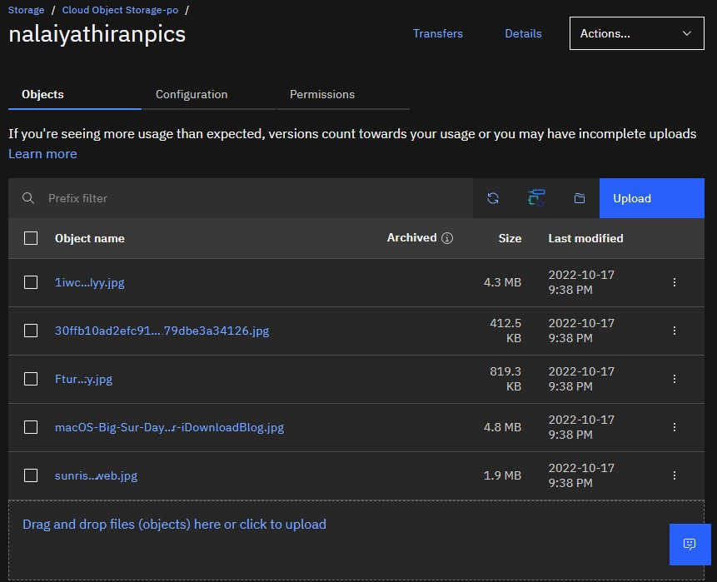

*2.Upload 5 images to IBM object storage and make it public. write html code to displaying all the 5 images.*

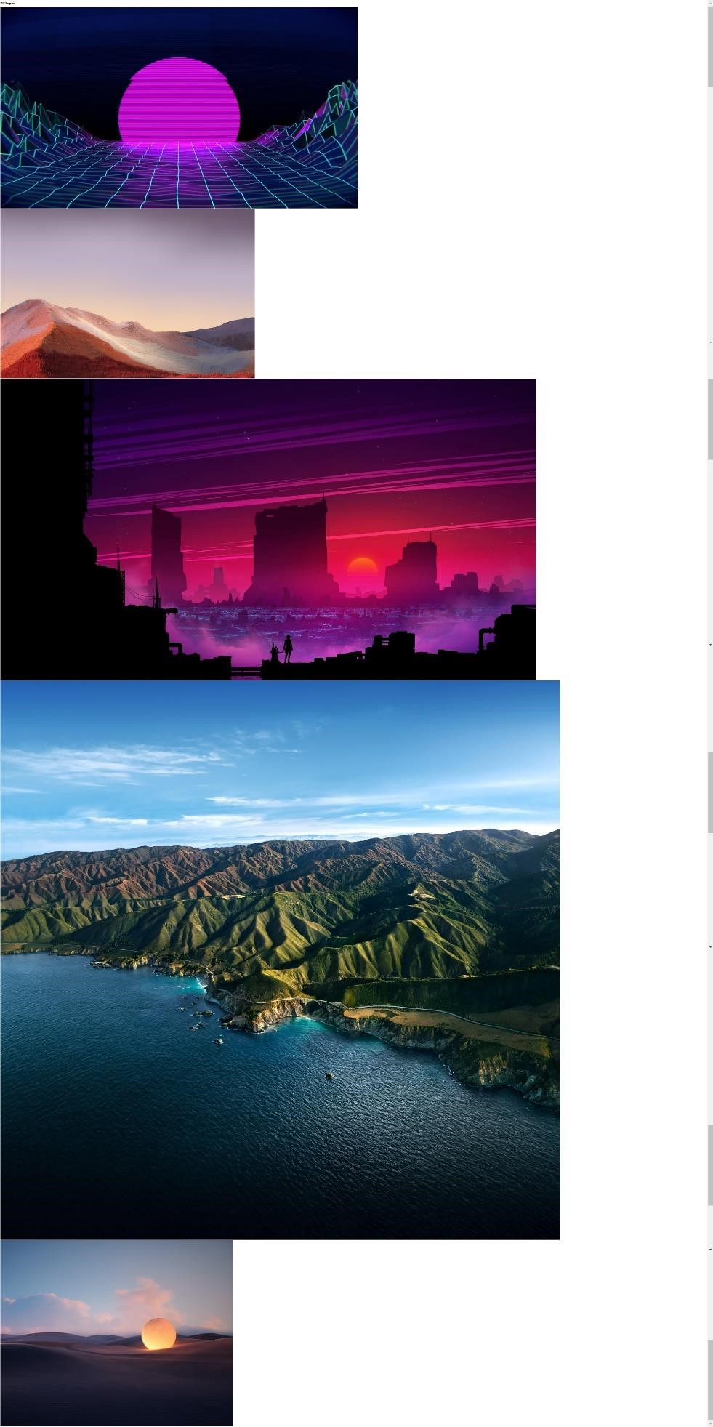

*3.Upload a CSS page to the object storage and use the same page in your HTML code.*

|  |
| --- |
| <!DOCTYPE *html*>  <html *lang*="en">  <head>  <meta *charset*="UTF-8">  <meta *http-equiv*="X-UA-Compatible" *content*="IE=edge">  <meta *name*="viewport" *content*="width=device-width, initial-scale=1.0">  <title>Wallpapers</title> <link *rel*="stylesheet" *href*="https://stackpath.bootstrapcdn.com/bootstrap/4.5.2/css/bootstrap.min.css " *integrity*="sha384-  JcKb8q3iqJ61gNV9KGb8thSsNjpSL0n8PARn9HuZOnIxN0hoP+VmmDGMN5t9UJ0Z" *crossorigin*="anonymous">    </head>  <body *style*="background-color:black;">  <div *class*="container">  <div *class*="row">  <div *class*="col-md-12">  <h1 *style*="color: white;">Wallpapers</h1>  </div>  </div>  </div>  <div *class*="container">  <div *class*="row">  <div *class*="col-md-4">  <img *src*="https://s3.au-syd.cloud-objectstorage.appdomain.cloud/nalaiyathiranpics/1iwcit1gidyy.jpg" *class*="img-fluid" *alt*="Responsive image">  </div>  <div *class*="col-md-4">  <img *src*="https://s3.au-syd.cloud-objectstorage.appdomain.cloud/nalaiyathiranpics/30ffb10ad2efc91e4feb25f6ff0179dbe3a3  4126.jpg" *class*="img-fluid" *alt*="Responsive image">  </div>  <div *class*="col-md-4">  <img *src*="https://s3.au-syd.cloud-objectstorage.appdomain.cloud/nalaiyathiranpics/Fture%20City.jpg" *class*="img-fluid" *alt*="Responsive image">  </div>  <div *class*="col-md-4">  <img *src*="https://s3.au-syd.cloud-objectstorage.appdomain.cloud/nalaiyathiranpics/macOS-Big-Sur-Daylight-WallpaperiDownloadBlog.jpg" *class*="img-fluid" *alt*="Responsive image"> </div>  <div *class*="col-md-4"> |

<img *src*="https://s3.au-syd.cloud-objectstorage.appdomain.cloud/nalaiyathiranpics/sunrise_hr_web.jpg" *class*="imgfluid" *alt*="Responsive image">

</div>

</div>

</div>

</body>

</html>

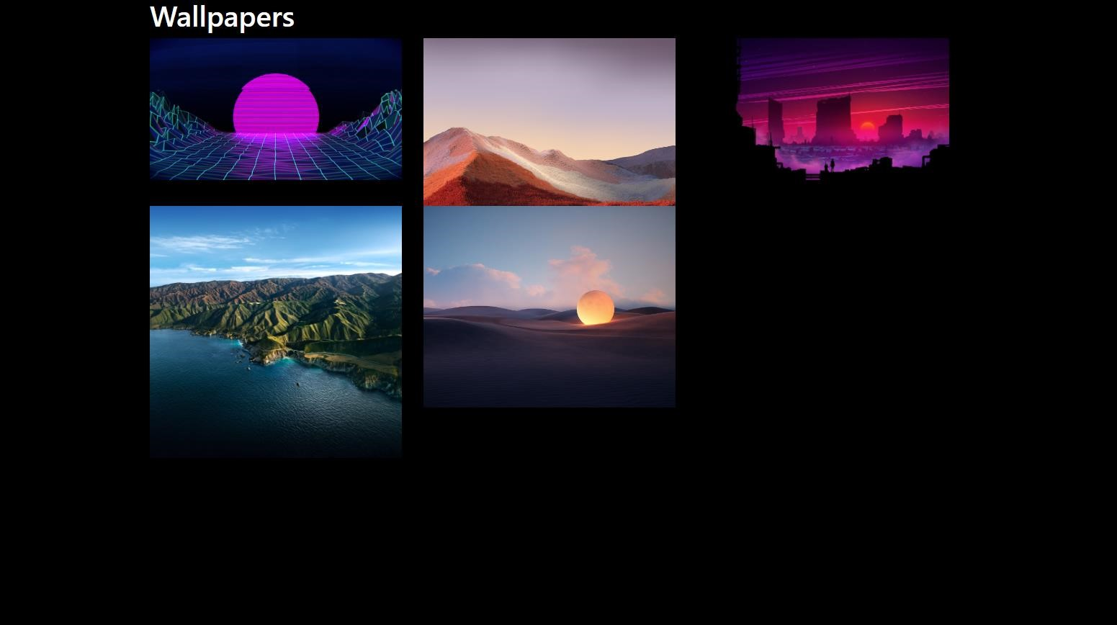

*4.Design a chatbot using IBM Watson assistant for hospital. Ex: User comes with query to know the branches for that hospital in your city. Submit the web URL of that chat bot as an assignment.*

[https://web-](https://web-chat.global.assistant.watson.appdomain.cloud/preview.html?backgroundImageURL=https%3A%2F%2Fau-syd.assistant.watson.cloud.ibm.com%2Fpublic%2Fimages%2Fupx-8d072d27-0ec3-4a0f-9bd9-f58db84c9b05%3A%3A6d0ce417-ce7c-4970-89c3-eb9a9c8aac01&integrationID=477cd525-6708-4d94-8661-a1f6ffdc24d9&region=au-syd&serviceInstanceID=8d072d27-0ec3-4a0f-9bd9-f58db84c9b05)

[chat.global.assistant.watson.appdomain.cloud/preview.html?backgroundImageURL=https%3A%2F% 2Fau-syd.assistant.watson.cloud.ibm.com%2Fpublic%2Fimages%2Fupx-8d072d27-0ec3-4a0f-9bd9f58db84c9b05%3A%3A6d0ce417-ce7c-4970-89c3-eb9a9c8aac01&integrationID=477cd525-67084d94-8661-a1f6ffdc24d9&region=au-syd&serviceInstanceID=8d072d27-0ec3-4a0f-9bd9f58db84c9b05](https://web-chat.global.assistant.watson.appdomain.cloud/preview.html?backgroundImageURL=https%3A%2F%2Fau-syd.assistant.watson.cloud.ibm.com%2Fpublic%2Fimages%2Fupx-8d072d27-0ec3-4a0f-9bd9-f58db84c9b05%3A%3A6d0ce417-ce7c-4970-89c3-eb9a9c8aac01&integrationID=477cd525-6708-4d94-8661-a1f6ffdc24d9&region=au-syd&serviceInstanceID=8d072d27-0ec3-4a0f-9bd9-f58db84c9b05)

*5.Create Watson assistant service with 10 steps and use 3 conditions in it. Load that script in HTML page.*

|  |
| --- |
| <script> window.watsonAssistantChatOptions = { integrationID: "477cd525-6708-4d94-8661-a1f6ffdc24d9", *// The ID of this integration.*  region: "au-syd", *// The region your integration is hosted in.*  serviceInstanceID: "8d072d27-0ec3-4a0f-9bd9-f58db84c9b05", *// The ID of your service instance.*  **onLoad**: function(instance) { instance.**render**(); } }; |
| **setTimeout**(function(){ const t=document.**createElement**('script');  t.src="https://webchat.global.assistant.watson.appdomain.cloud/versions/" +  (window.watsonAssistantChatOptions.clientVersion || 'latest') +  "/WatsonAssistantChatEntry.js";  document.head.**appendChild**(t);  });  </script> |

